Year 1 Autumn A Theme – Life Histories

This half term our pupils will be learning about themselves and the people who are important in their lives.
We will be using pictures, photos, stories, and role play to help pupils explore these ideas in a way that is fun and meaningful.
We will focus on four key topics:
- My Story – learning about each pupil’s own life, including their likes and dislikes, special memories, and things that make them unique.
- Friends – exploring who our friends are and learning how to play, share, and be kind to others.
- Families – talking about the people who care for us and understanding different family roles.
- Important Figures – finding out about special people in our lives and people in the wider world who help or inspire us.
These activities will help pupils to build their sense of self and develop their understanding of relationships, belonging, and community

Core Subjects
Maths  Counting– Oral Counting (week 1-3)  - Bulb – To show increased familiarity with number songs and stories.  - Branch – To verbally count forwards and/or backwards within an extending counting range. To recognise numbers within known counting range.  - Blossom - To verbally recount numbers in ascending/ descending order whilst extending the largest number they can count to/ from and to identify and label numbers of an increasing range, when presented in isolation.  Pattern – Shape/Colour (week 4-6)  - Bulb – To explore colour and shape in multi-sensory activities to support the development of their vocabulary and communication in various settings.  - Branch – Pupils to develop visual skills to identify similarities and differences between items and expand their vocabulary related to colour/ shape to aid communication.  - Blossom – Pupils to develop visual skills to identify similarities and differences between items and expand their vocabulary related to colour/ shape to aid communication. | English  Language Comprehension – Listening & Attention  - Bulb: To listen to familiar adults tell sensory and other stories one-on-one.  - Branch:To listen to and join in with a range of poems, stories, rhymes, and songs with different adults, both 1:1 and in small groups.  - Blossom: To listen attentively to a wide range of texts and speakers, including fiction and non-fiction, in various group sizes and contexts, and begins to recite rhymes and poems by heart.  Reading Comprehension – Vocabulary  - Bulb – To understand and use familiar vocabulary to identify and label relevant objects and images in stories.  - Branch - To respond to printed words by matching them to objects or images and identifying different word classes such as verbs and adjectives.  - Blossom - Demonstrates growing vocabulary and comprehension by matching words and sentences to images, acting out verbs, using synonyms and definitions, and applying new vocabulary across contexts using various strategies. | Science  My Body  - Identifies and labels body parts that are external, internal and private.  - Understands changes occur as we grow.  - Understand the needs and functions of our bodies.
PSHE- Myself & Others (potential units, selected on a pupil-by-pupil basis)
- Recognises personal strengths, uniqueness, and goals for the future.
- Respects similarities and differences between people and communities.
- Understands the importance of kindness and knows how to respond to unkind behaviour, including online.

Other activities you can complete at home
PE – Explore fundamental skills that form the foundation for more complex physical activities, sports, and active play. These include three main area:
- Locomotor skills-(moving the body from one place to another) walking, running, jumping, skipping.
- Manipulative skills- (handling or controlling objects, usually with the hands or feet) throwing, catching, kicking, bouncing.
- Stability skills- (maintaining balance and controlling body position) balancing, turning, bending climbing.

Art/ Crafts – Alongside building key vocabulary and fine motor skills, we will also be exploring cross-curricular learning through fun, hands-on activities like playdough face mats, DIY x-rays using cotton buds or pasta, and creative self-portraits made from everyday materials.
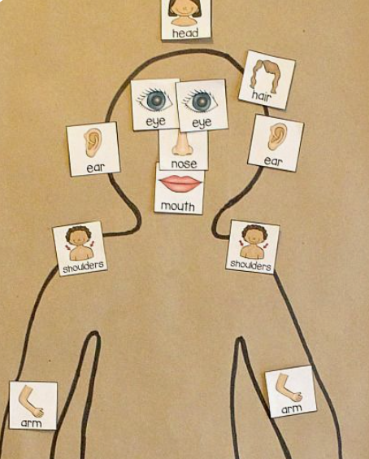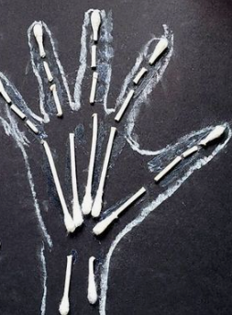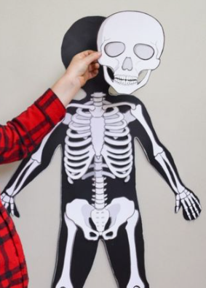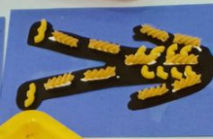

Humanities
- Sequence photos of the pupil from baby → toddler → now.
- Create an “All About Me” book with pictures of favourite foods, toys, and places.
- Match family members’ photos to symbols or labels (e.g., mum, dad, brother).
- Sort pictures into “family” vs “not family.”
- Build a simple family tree using photos.

Outcomes:
- ALL – Develop self-awareness of similarities and differences with others and themselves at different life stages.
- MOST – Develop an understanding of my own emotions.
- SOME – Develop skills to make independent choices for future planning based on skills and interests.

Year 1 Autumn A Life Histories - Key Texts

Topic | Photo | Title
My Story |  | - Super Duper You!  - I Love Me!  - You Can!  - Be You!  - The One and Only You
Friends |  | - Mini Monsters- Can I Play?  - On Sudden Hill  - The Same but Different Too  - Little Blue Truck  - Elmer’s Friends
Families |  | - My Family Your Family  - All Kinds Of Families  - Who’s In My Family? All About Our Families  - We are Family  - In Every House, On Every Street.
Important figures |  | - Together We Ride  - The dot  - Last Stop on Market Street

